Apps for the Classroom

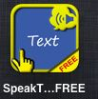 | Speaks text from webpages or text typed into the app.
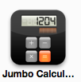 | Large calculator great for students that need help with fine motor.
 | Charts are easy to make and for students to enter their own data.
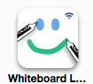 | This program can connect with another iPad and is great to get students to work together and for individual practice.
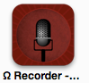 | This app is good for recording students reading.
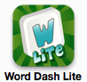 | Helps students build vocabulary as they try to get all the words out of 6 letters they can.
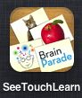 | Customizable program to create choices for students.
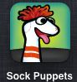 | Students speak for puppets and record their “play”. Then the program scrubs their voice so the student’s voice can’t be recognized. Videos can also be uploaded to YouTube.
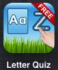 | Students are asked to click on a specific letter. They’re given 4-6 letters at a time.
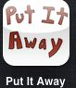 | Students drag items to put them away.
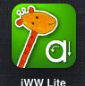 | Word tracing game. There are arrows on the proper way to make the letters.
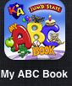 | Drag stamps that go with a letter of the alphabet. In read mode it reads back the pictures.
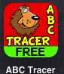 | Number tracing game.
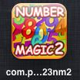 | Number matching game.
 | Fraction game using pizzas.
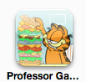 | Fact and Opinion game. This game is based on the internet safety work done through Professor Garfield so that they learn internet safety while practicing determining facts and opinions.
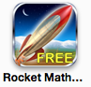 | Basic math operations game. Students love playing this game.
 | Counting money.
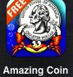 | Counting money and coin recognition.

