Directions for Redeeming App Codes Directly on Device

Step 1
Make sure you’re logged into your new iTuens account. To do this, go to the Settings app and scroll down to iTunes & App Stores. When you click on that you will see the Apple ID that your device is currently logged into.

You may need to sign out of another account and sign into your new account.

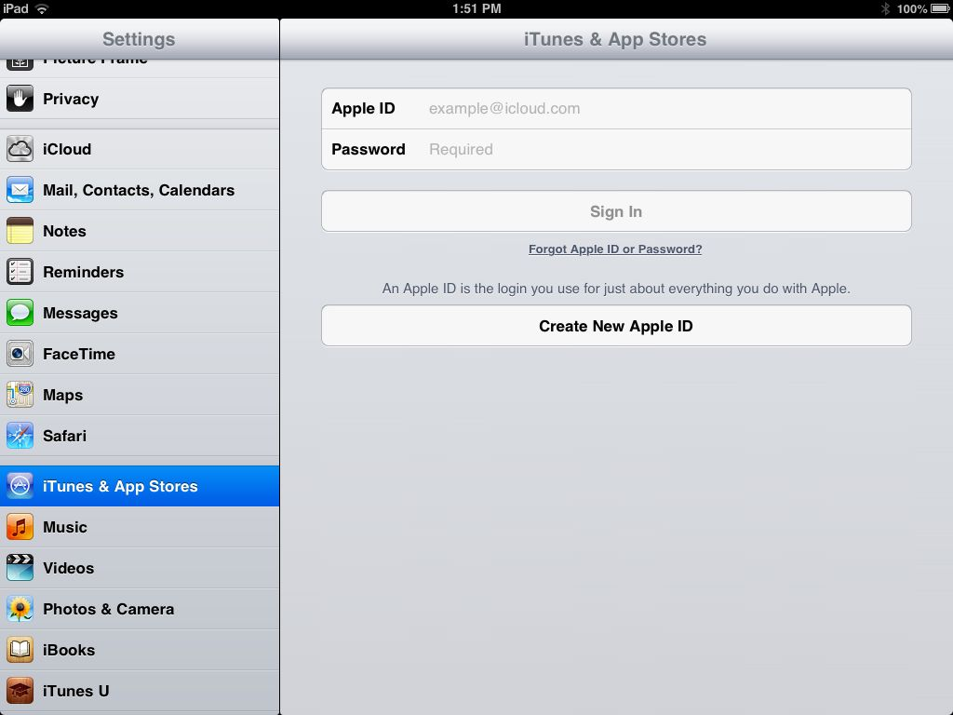

Step 2
Open the App Store App and scroll to the bottom of the “Featured” screen until you see a “Redeem” button.

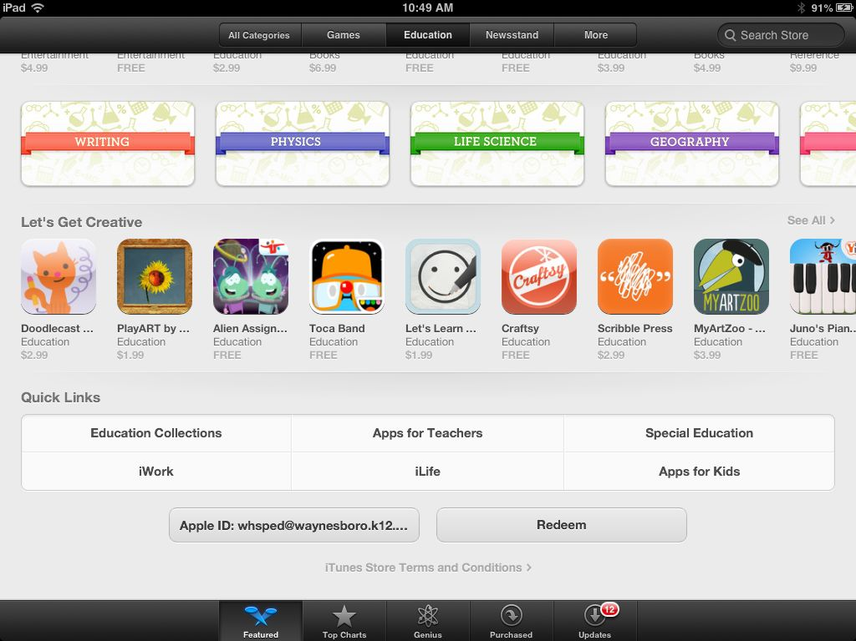

Step 3
Enter the redeem code from the e-mail and click “Redeem”. It will now install the app onto your device.

